**Day 12**

**Service management**

**Definition:**

Service management to linux refuses to the process of controlling and monitoring various services the runs in the background provide specific functionality are futures to the system.

**To Check Running of service**

**1.usind to list of service command is Systemctl list -units - -type=service**

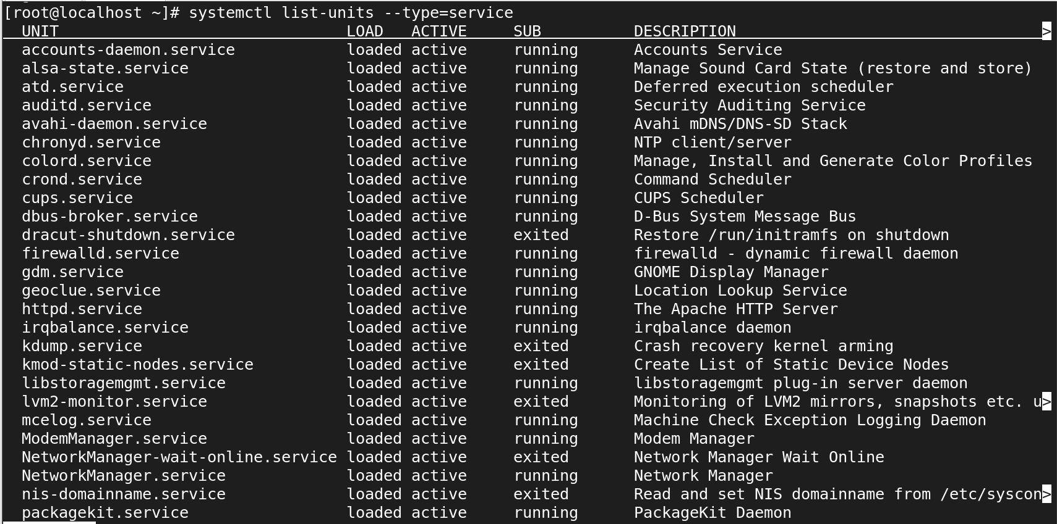

**2.Using to install the command and packagename is yum install firewalld**

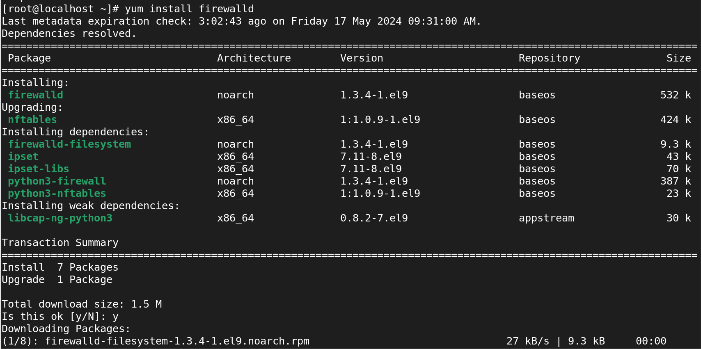

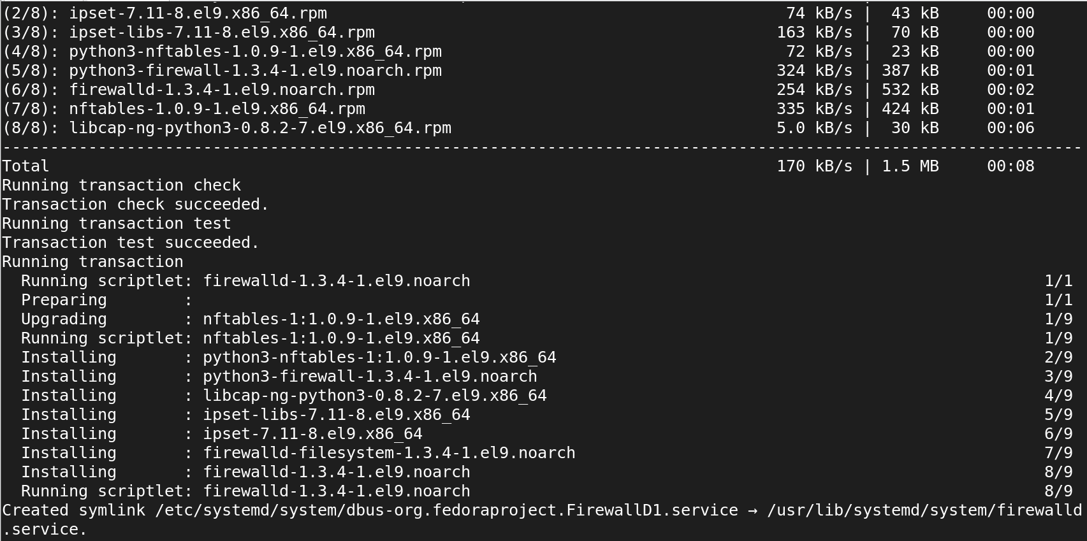

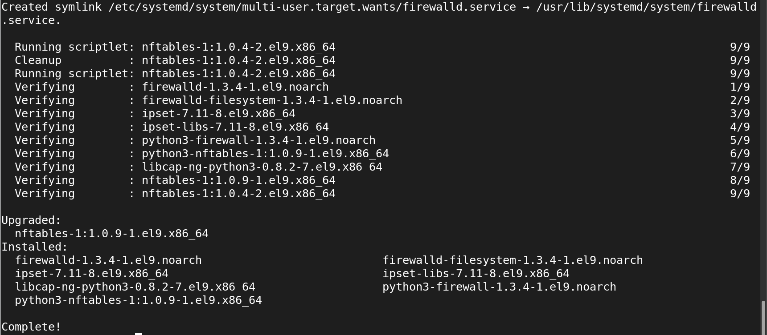

**3.using to start the service command is systemctl start firewalld.service and status also viewed command is systemctl status firewalld.service**

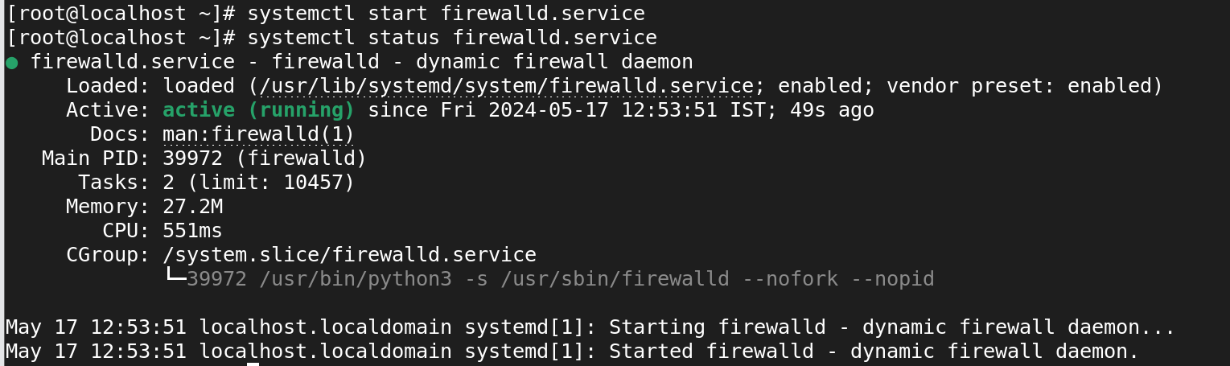

**4.using to stop the service command is systemctl stop firewalld.service and status also viewed command is systemctl status firewalld.service**

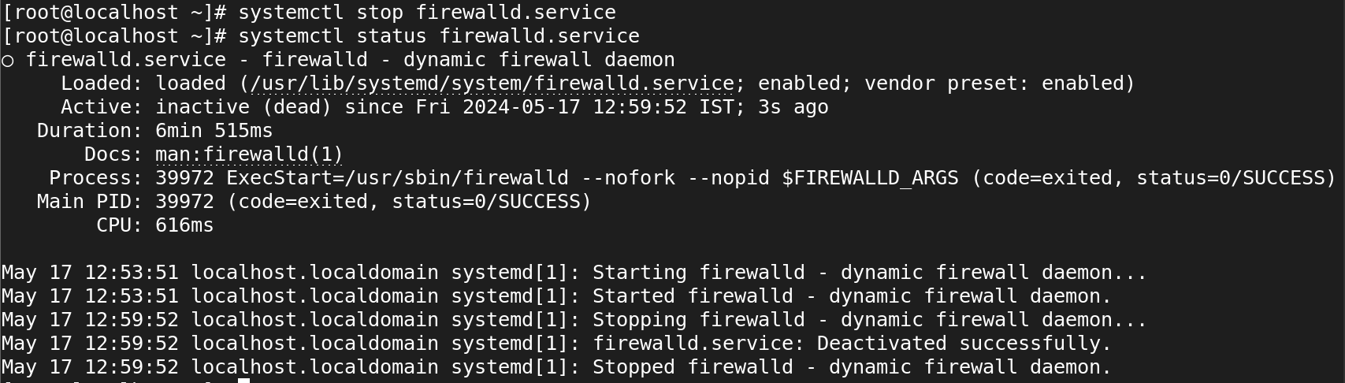

**5.using to enable the service command is systemctl enable firewalld.service and status also viewed command is systemctl is-enabled firewalld.service**



**6.using to disable the service command is systemctl disable firewalld.service and status also viewed command is systemctl is-enabled firewalld.service**

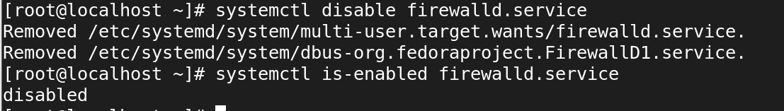

**7.using to restart the service command is systemctl restart firewalld.service and status also viewed command is systemctl status firewalld.service**

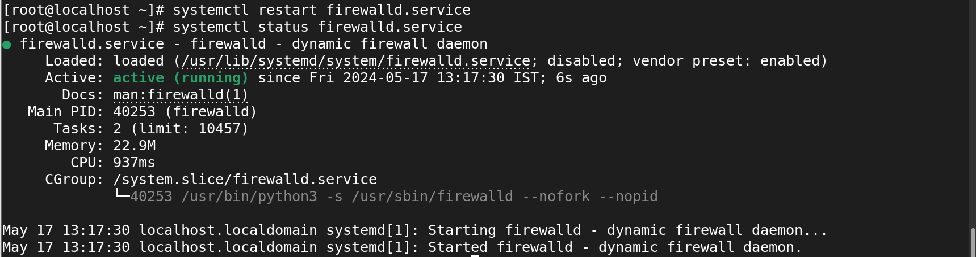

**8.using to reload the service command is systemctl reload firewalld.service and status also viewed command is systemctl status firewalld.service**

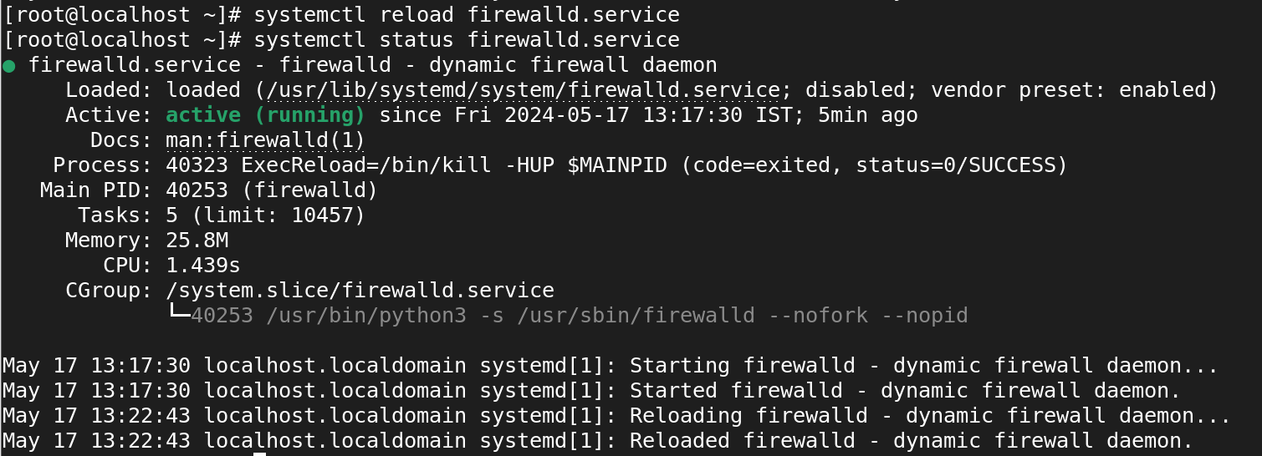

**9.using to remove the service command is yum remove firewalld**

